Group - 9, Section - B1

|  |  |  |  |  |  |  |  |  |  |  |  |  |  |  |  |  |
| --- | --- | --- | --- | --- | --- | --- | --- | --- | --- | --- | --- | --- | --- | --- | --- | --- |
| OPCODE | | | | CODE | Operation | ALU  Operation | ALU Selection | | RegDST | ALUSRC | MemToReg | RegWrite | MemRead | MemWrite | Branch | Jump |
| OP3 | OP2 | OP1 | OP0 | S1 | S0 |
| 0 | 0 | 0 | 1 | I | lw | Add | 0 | 0 | 0 | 1 | 1 | 1 | 1 | 0 | 0 | 0 |
| 0 | 0 | 1 | 0 | J | sw | Add | 0 | 0 | X | 1 | X | 0 | 0 | 1 | 0 | 0 |
| 0 | 0 | 1 | 1 | K | beq | Sub | 0 | 1 | X | 0 | X | 0 | 0 | 0 | 1 | 0 |
| 0 | 1 | 0 | 0 | L | j | X | X | X | X | X | X | 0 | 0 | 0 | X | 1 |
| 0 | 1 | 0 | 1 | C | addi | Add | 0 | 0 | 0 | 1 | 0 | 1 | 0 | 0 | 0 | 0 |
| 0 | 1 | 1 | 0 | H | ori | OR | 1 | 1 | 0 | 1 | 0 | 1 | 0 | 0 | 0 | 0 |
| 0 | 1 | 1 | 1 | A | add | Add | 0 | 0 | 1 | 0 | 0 | 1 | 0 | 0 | 0 | 0 |
| 1 | 0 | 0 | 0 | G | or | OR | 1 | 1 | 1 | 0 | 0 | 1 | 0 | 0 | 0 | 0 |
| 1 | 0 | 0 | 1 | B | sub | Sub | 0 | 1 | 1 | 0 | 0 | 1 | 0 | 0 | 0 | 0 |
| 1 | 0 | 1 | 0 | E | and | AND | 1 | 0 | 1 | 0 | 0 | 1 | 0 | 0 | 0 | 0 |
| 1 | 0 | 1 | 1 | D | subi | Sub | 0 | 1 | 0 | 1 | 0 | 1 | 0 | 0 | 0 | 0 |
| 1 | 1 | 0 | 0 | F | andi | AND | 1 | 0 | 0 | 1 | 0 | 1 | 0 | 0 | 0 | 0 |

**ICs**

1. ALU - IC74LS381
2. ROM - IC2764
3. 2114
4. 2732

**Functions**

1. S1 =  BD' + AD'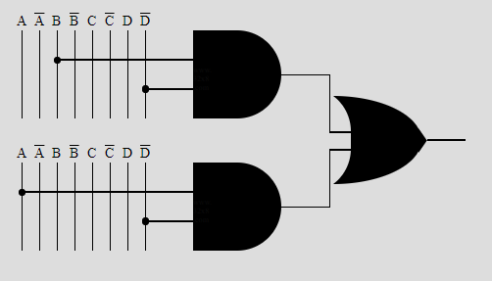
2. S0 = B'CD + AB'C' + A'BD'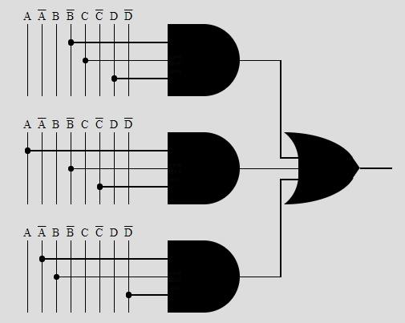
3. RegDST = B'D' + AB'C' + A'CD
4. ALUSCR­=A'C' + A'D' + BC' + ACD 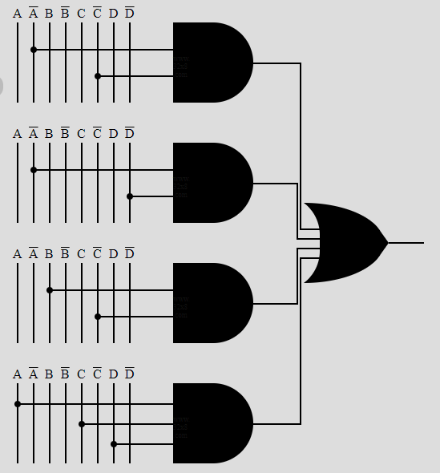
5. MemToReg=A'B' 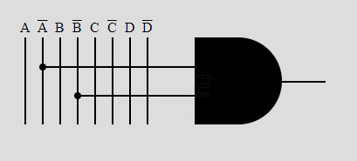
6. RegWrite = A + C'D + BC 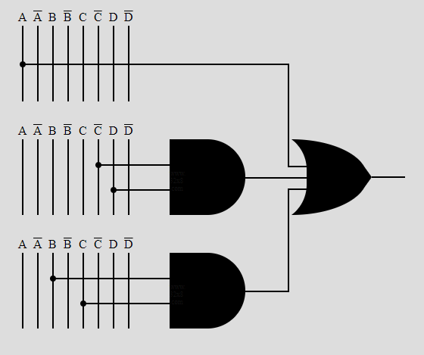
7. MemRead =A'B'C' 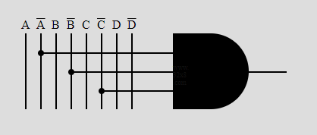
8. MemWrite =A'B'D' 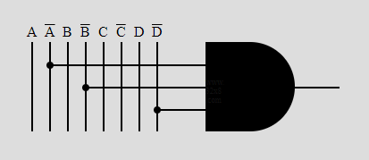
9. Branch = A'B'CD 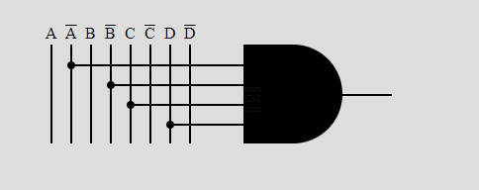
10. Jump =  A'C'D' 